Exercise #1
CSCI 214: Server-Side Admin and Programming

Overview

Our servers are up and running, and it is time to do less server admin and more web dev! Our first task is to make a responsive website that works on any device. It should consist of two pages: a welcome page, and a page with a survey form.

Technology Stack

You will, of course, be using HTML, CSS, and Javascript to build out any web projects we do in this class. While I’m happy to assist people with the occasional curve ball, I will not be lecturing or covering how to do this kind of web development in class – I’m counting on your experience in CSCI 181 to cover you.

I will insist that you utilize the Bootstrap framework for web development (which may be new to you). It includes excellent CSS already pre-written for you, includes features for responsive layout, and is integrated with the excellent jQuery javascript library. We will talk about this content in a class session.

Since we’re moving toward interacting with the user and doing server-side programming, we’re going to need to use HTML forms for the user to interact with.

Objectives

- Home page utilizing Bootstrap nav to provide links to navigate the site.

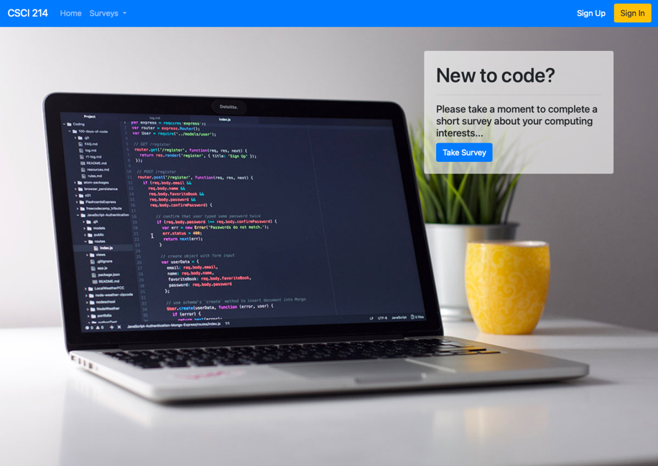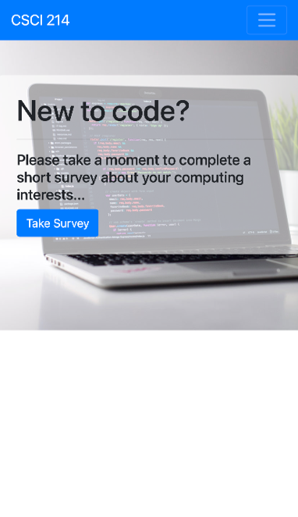
- (Suggestion) Below the nav should be some kind of large, welcoming image. Sitting atop the image and toward the right hand side should be a block of text welcoming people and encouraging them to take the survey. A button should be present to link the user directly to the survey page. You need to design some kind of visually appealing page – if you don’t want to use the suggestion, that is fine, but you have to design out something.
- Survey page should also include the nav, and be of a visually appealing design. The main feature of the page should be a form that surveys the user regarding a topic of your choice (not the topic on my page, illustrated below). Your form must include at least one question using each of the following HTML form elements:
  - Text input (please request the user's name with one of these)
  - Textarea
  - Select (pop-up menu, single selection)
  - Radio buttons (forcing a single selection)
  - Checkboxes (allowing for multiple selection)
  - A submit button

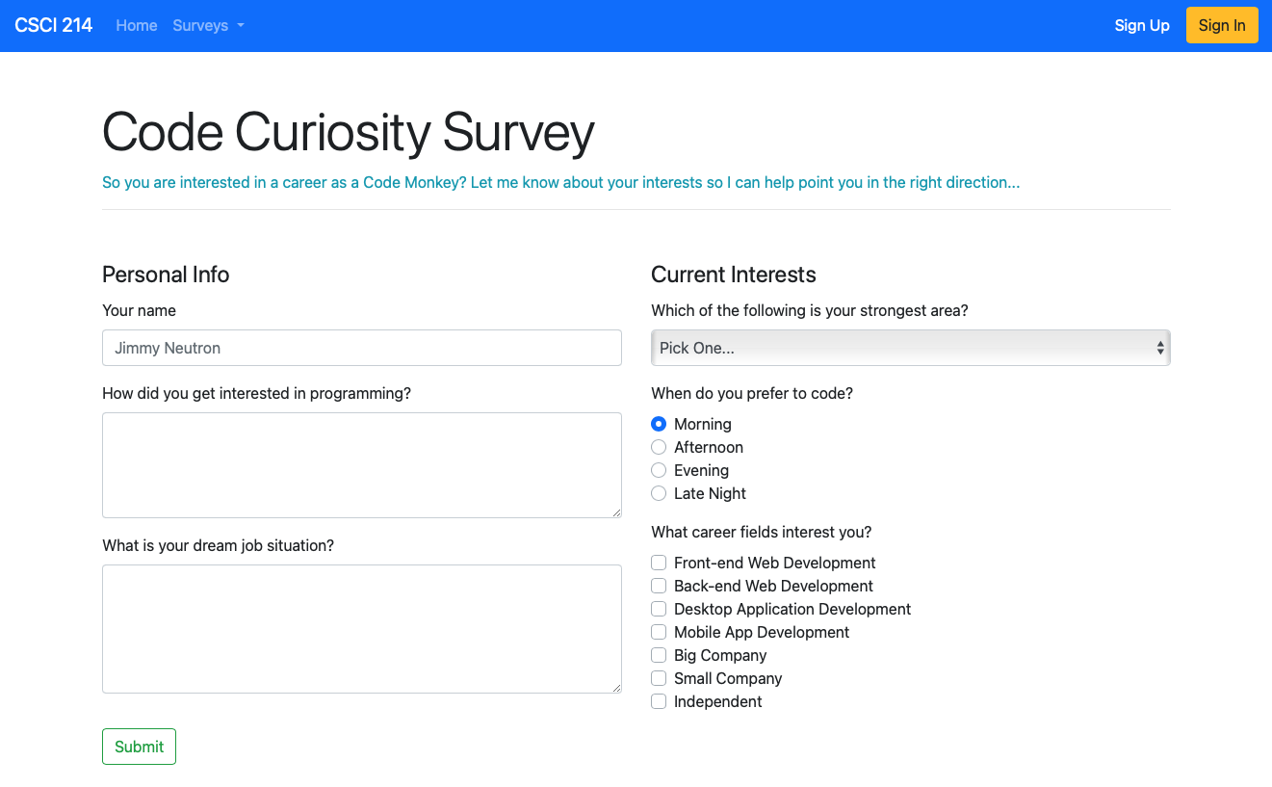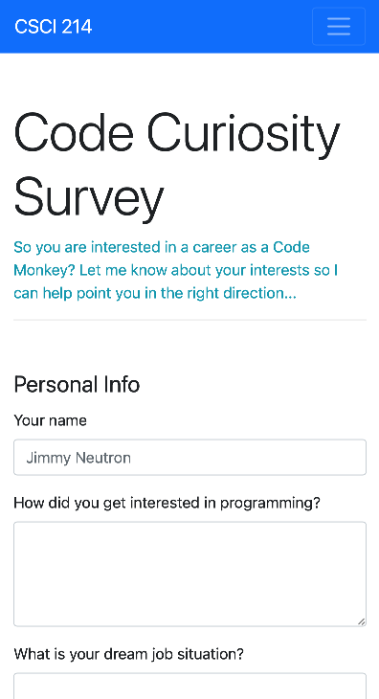

Resources

Consider using the following resources while building out the site:

https://unsplash.com – free, high quality photos
https://getbootstrap.com – the source for Bootstrap, featuring excellent documentation
http://jquery.com – documentation for jquery
https://www.w3schools.com – Somehow, I always end up here when trying to work out some HTML syntax detail…

Completion

Once you are done with this assignment, give me a link to your site. Hand it in at D2L > Assignments > Project 1.

